23.24: a) 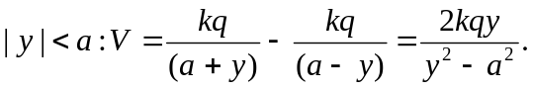
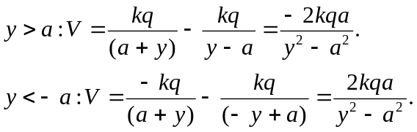
Note: This can also be written as 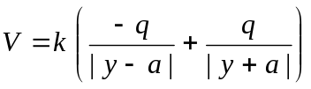
b)
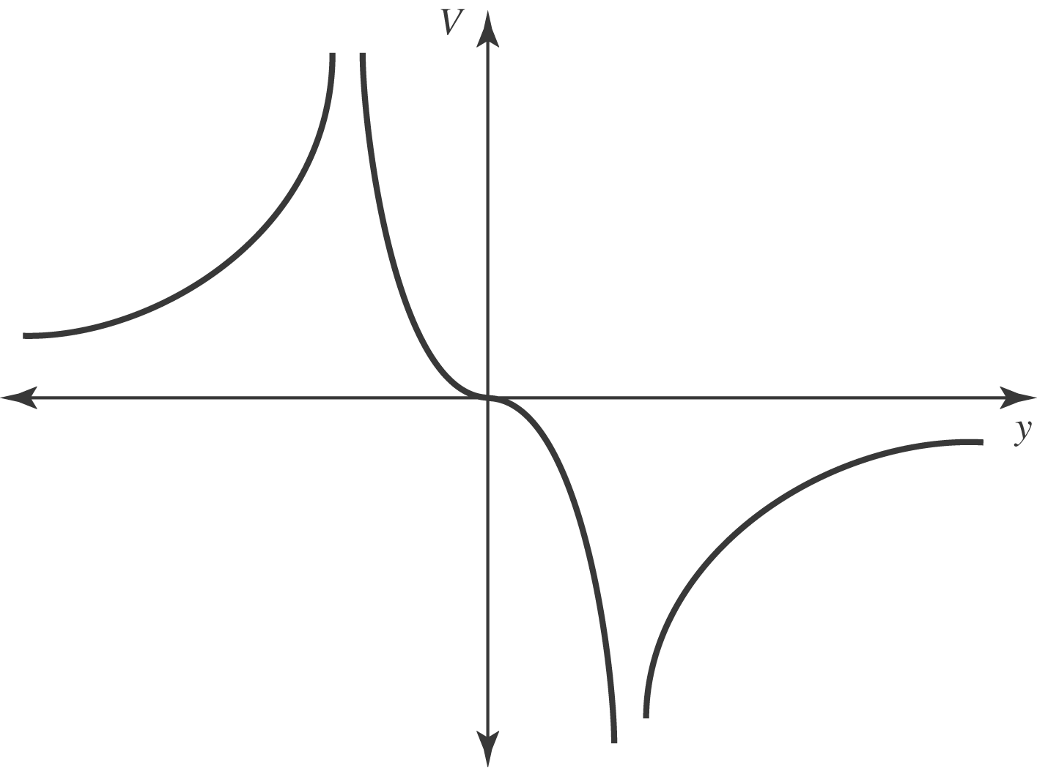
c) 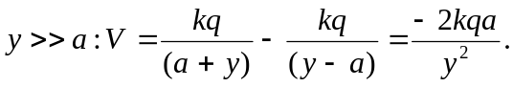
d) If the charges are interchanged, then the potential is of the opposite sign.

